**Image compression in the context of Pression livestock farming**

|  |  |  |  |
| --- | --- | --- | --- |
| Sebastián Amaya  Universidad Eafit  Colombia  saamayac@eafit.edu.co | Daniel Gómez Vargas  Universidad Eafit  Colombia  Dgomezv9@eafit.edu.co | Simón Marín  Universidad Eafit  Colombia  smaring1@eafit.edu.co | Mauricio Toro  Universidad Eafit  Colombia  mtorob@eafit.edu.co |

ABSTRACT

This text revolves around image compression in the context of pression livestock farming (PLF), in it we analyze different approaches to PLF and at the same time explain some of the algorithms used in image compression all of this to give a clearer picture of the subject at hand.

Keywords:

Compression algorithms, machine learning, deep learning,   
precision livestock farming, animal health.

1. INTRODUCTION

The world population is expected to peak at the beginning of the 22nd century with an expected total population of 10.88 billion [6], this present a lot of challenges but one of them is food supply or food production, for the purpose of this text we are focused on livestock farming, where both production and consumption have steadily grown [5],

|  |  |  |
| --- | --- | --- |
| Products | Production (1961 - 2018) | Percapita supply (1961 - 2013) |
| Meat | +271.06 million Tonnes | +20.14 kg |
| Milk | +497.66 million Tonnes | +14.45 kg |
| eggs | +67.75 million Tonnes | +4.64 kg |

Is this growth as well as the climate crisis, that have raised the need for farms to be more efficient but at the same time prioritize the reduction of the disruption in the environment as well as animal wellbeing, which are all objectives of presession livestock farming (PLF) [4], PLF is “...a holistic approach that adds information and communication technologies (ICT) to improve the farming process.” one specific part of PLF is use image recognition, mainly for identification, checking animal health and so forth, image recognition in PLF can generates a lot of data, and over time this can become problematic because of the amount of storage need and other factor, in relation to the first one compressing the images can go a long way in helping saving energy, and hardware capacity.

1.1. Problem

The problem of finding an algorithm with the best efficiency and better image compression to identify very accurately when an animal is sick or healthy in the context of livestock farming, would be the result of an automation and optimization of the work to generate an order and a clear and accurate information, which correctly recognize which are the animals that present pictures of risky health and thus reduce the risk of diseases, viruses and infectious batteries and allow a rapid intervention.

1.2 Article structure

In what follows, in Section 2, we present related work to the problem. Later, in Section 3, we present the data sets and methods used in this research. In Section 4, we present the algorithm design. After, in Section 5, we present the results. Finally, in Section 6, we discuss the results, and we propose some future work directions.

2. RELATED WORK

In what follows, we explain four related works on the domain of animal-health classification and image compression in the context of PLF.

2.1 Automatic weight estimation of individual pigs using image analysis

In this work they tested out the possibility of measuring pigs weight using image analysis, this study contains measurements on four pens of grower pigs (each of the pens monitors by a top view camera), shape recognition techniques were employed to identify each pig using the shapes painted on the bag of the pigs,

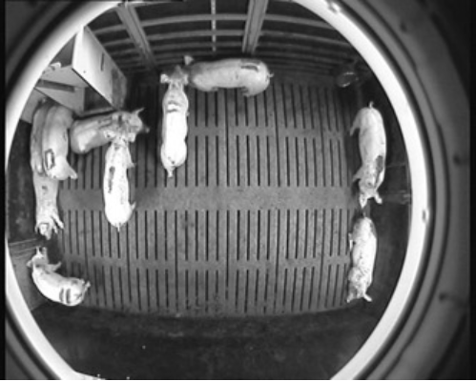

Figure 1: “A frame of a video showing a top view of one of the four pig pens in the research barn.” [1]

after identifying a pig, the weight estimation process begins; first the pig is located via an ellipse fitting algorithm, then the area the pig occupies inside the ellipse and lastly the weight is estimated by a dynamic model. This process achieved an accuracy of 97.5% at a group level, better than existing automated tools (95%) or walk-thought systems (97%). [1]

2.2 Lameness detection of dairy cows based on the YOLOv3 deep learning algorithm and a relative step size characteristic vector

This work proposes a solution the problem of lameness (“the clinical manifestation of painful disorders, mainly related to the locomotor system, resulting in impaired movement or deviation from normal gait or posture”[3]) in dairy cows and by extension the cow’s welfare and productivity [3] in this study a method base on the YOLOv3 deep learning algorithm and relative step size characteristic vectors, the method first calculates the relative step size of the cows legs (front and rear) using the leg coordinates then the relative step size characteristic vectors is constructed and lastly a trained Long Short-Term Memory (LSTM) classification model classified the cows in lameness and non-lameness based on the characteristic vector.

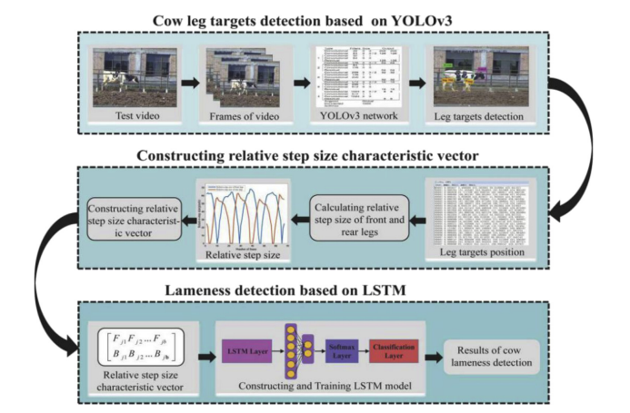

Figure 2: “Technical route of the proposed method” [2]

This method resulted is higher accuracy rate as well as a higher True positive rate compere to other methods like the support vectors machine or decision tree classifier. [2]

2.3 Research on image compression technology based on Huffman coding

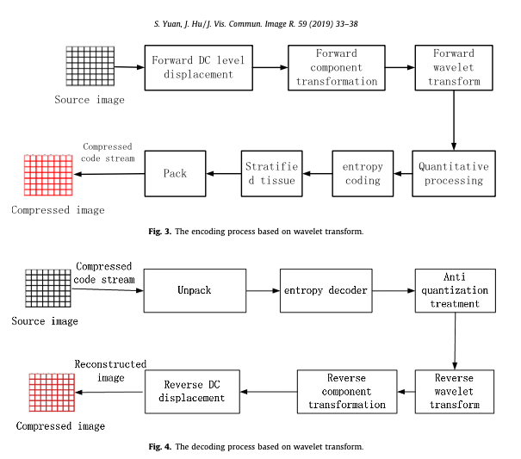

2.4 ESTUDIO DE LA CODIFICACIÓN PREDICTIVA DE IMÁGENES BASADA EN CÓDIGOS RICE

In this work they set two main objectives. The first objective is to achieve a minimum sending bit rate by predictively coding images with Rice codes, and the second is to see if the bit rate differs from other coding techniques.

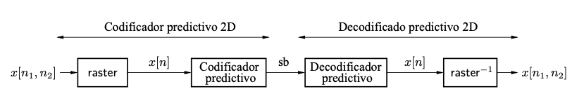

Figure 8: Schematic of a predictive coding system for images.

In this work they found that it is a good option to use an adaptive predictor and adaptive Rice coding, as long as our priority is the minimum bit rate value, and the complexity of the algorithm is not relevant because when using the JPEG-LS predictor it was observed that the bit rate is lower than using a fixed predictor and also, with an adaptive predictor the bit rate is reduced but the implementation of this is a little more complex.

3. MATERIALS AND METHODS

In this section, we explain how the data was collected and processed and, after, different image-compression algorithm alternatives to solve improve animal-health classification.

3.1 Data Collection and Processing

We collected data from Google Images and Bing Images divided into two groups: healthy cattle and sick cattle. For healthy cattle, the search string was “cow”. For sick cattle, the search string was “cow + sick”.

In the next step, both groups of images were transformed into grayscale using Python OpenCV and they were transformed into Comma Separated Values (CSV) files. It was found out that the datasets were balanced.

The dataset was divided into 70% for training and 30% for testing. Datasets are available at https://github.com/mauriciotoro/ST0245-Eafit/tree/master/proyecto/datasets .

Finally, using the training data set, we trained a convolutional neural network for binary image-classification using Google Teachable Machine available at https://teachablemachine.withgoogle.com/train/image.

3.2 Lossy Image-compression alternatives

In what follows, we present different algorithms used to compress images.

3.2.1 discrete cosine transform compression

The process starts by normalizing all the gray pixels, so they range from –128 to 127, then each of the 8 x 8 block (this algorithm works with 8x8 blocks of an image) is separately encoded with a DCT coefficient (each of the coefficients represents a weight of the cosine wave corresponding to the location), the output is the coefficient matrix, the complexity of this algorithm is O(n^4) for each 8x8 block [9]

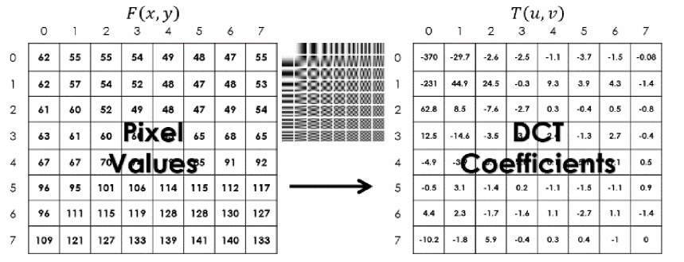

3.2.2 Quantization compression

Quantization compression is a lossy compression algorithm it happens by the process of eliminating higher frequency data (it is applied after the DCT in JPEG image compression), the quantization function where every coefficient is divided by a corresponding quantization value (the matrix of quantization values is normally called quantized block), as previously stated the goal of this algorithm is to reduce most of the higher frequency data, the complexity of the O(n^2) or O(N) n being every pixel in the image.[9]

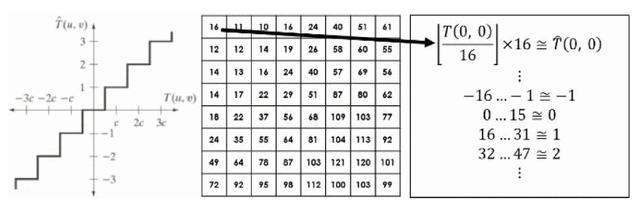

3.2.3 Fractal compression

The algorithm is Lossy Image-compression used for image compression and to represent image graphics, the algorithm represented the image in fractal code, and this fractal code is then used to decoded it. [10]

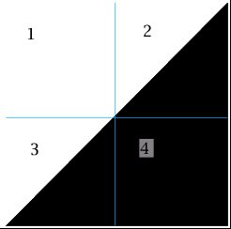

Figure: “triangles, example to show how fractal compression works” [11]

3.2.4 Color cell compression

The Color cell compression is a Lossy Image-compression algorithm used for color images, it is based on block truncation coding, and it has three phases and can achieve a compression of 2 bits/pixel.[12]

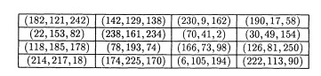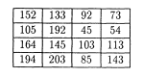 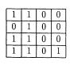

Figure: on the right a 4x4 color cell E, on center luminance channel of example cell E, on the left Bitmap B of example cell E [12]

3.3 Lossless Image-compression alternatives

In what follows, we present different algorithms used to compress images. (In this semester, examples of such algorithms are Borrows & Wheeler Transform, LZ77, LZ78, Huffman coding and LZS).

3.3.1 Huffman Compression

In Huffman coding, input string characters are assigned with variable length codes (bit sequences), and the frequency of individual character determines the allocated code length.

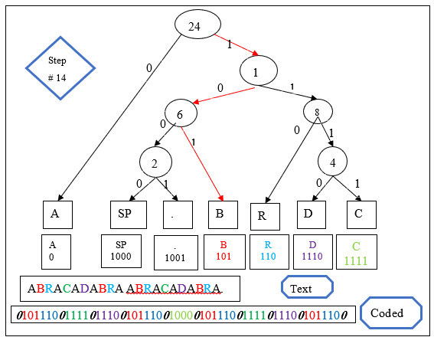

3.3.2 LOCO-I lossless image compression

the main objective driving the design of LOCO-I is to systematically “project” the image modeling into a low complexity plane, both from a modeling and coding perspective.

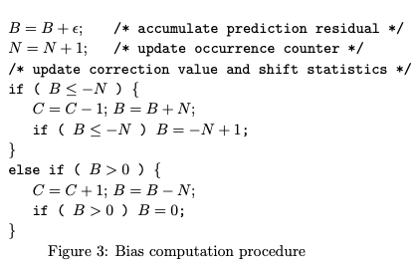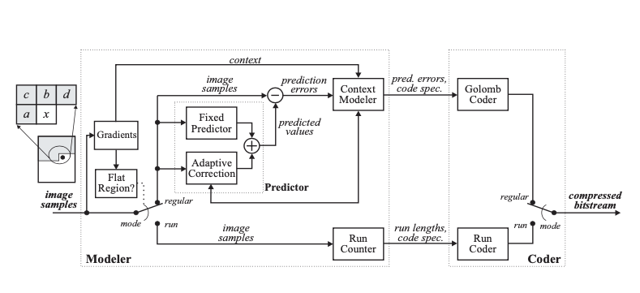

3.3.3 Rice coding

In this work, monochromatic images of 8 bits per pixel were considered. Therefore, each pixel takes an integer value between 0 and 255 (X = {0,1,...,255}).

Two predictors were considered: a fixed predictor and an adaptive predictor. The fixed predictor used is the first difference predictor. In this predictor, each sample x[n] resulting from the raster scan is predicted by a first-order predictor with a1 = 1:

x ̃[n] = x[n - 1]

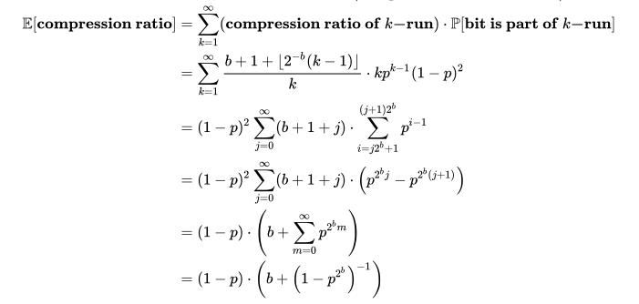

3.3.4 A Block-sorting Lossless Data Compression Algorithm

This algorithm transforms a string S of N characters by forming the N rotations (cyclic shifts) of S, sorting them lexicographically, and extracting the last character of each of the rotations. A string L is formed from these characters, where the ith character of L is the last character of the ith sorted rotation

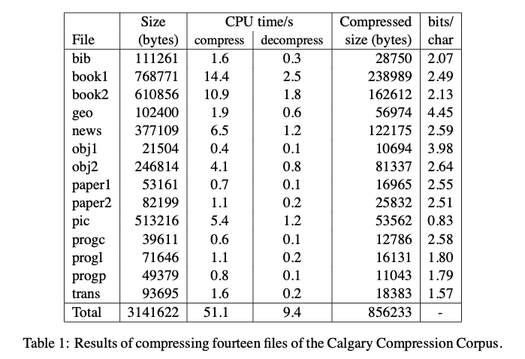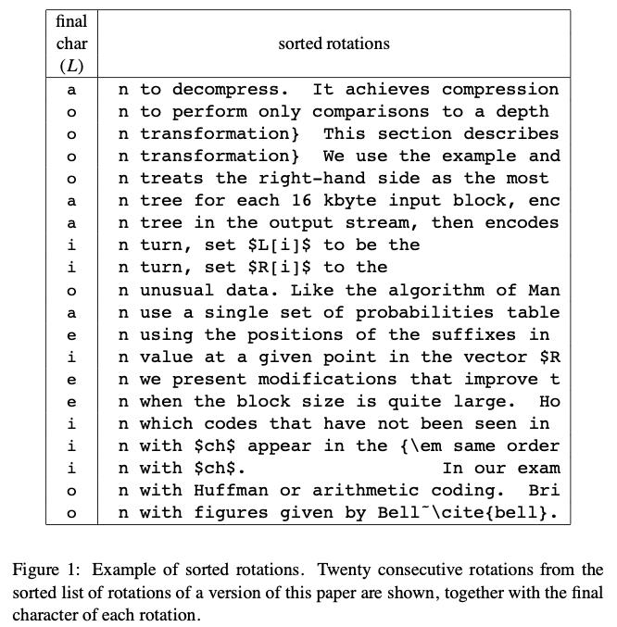

REFERENCES

[1] Mohammadamin Kashiha, Claudia Bahr, Sanne Ott, Christel P.H. Moons, Theo A. Niewold, Frank O. Ödberg, Daniel Berckmans. Automatic weight estimation of individual pigs using image analysis.   
Computers and Electronics in Agriculture volume 107, September 2014, Pages 38-44.

[2] Dihua Wu, Qian Wu, Xuqiang Yin, Bo Jiang, Han Wang, Dongjian He, Huaibo Song. Lameness detection of dairy cows based on the YOLOv3 deep learning algorithm and a relative step size characteristic vector. Biosystems Engineering Volume 189, January 2020, Pages 150-163

[3] Annelies Van Nuffel, Ingrid Zwertvaegher, Liesbet Pluym, Stephanie Van Weyenberg, Vivi M. Thorup, Matti Pastell, Bart Sonck and Wouter Saeys. Lameness Detection in Dairy Cows: Part 1. How to Distinguish between Non-Lame and Lame Cows Based on Differences in Locomotion or Behavior. Published online 2015 Aug 28, Retrieve from: [Lameness Detection in Dairy Cows: Part 1. How to Distinguish between Non-Lame and Lame Cows Based on Differences in Locomotion or Behavior (nih.gov)](https://www.ncbi.nlm.nih.gov/pmc/articles/PMC4598709/#B10-animals-05-00387)

[4] Rodrigo García, Jose Aguilar, Mauricio Toro, Angel Pinto, Paul Rodríguez. A systematic literature review on the use of machine learning in precision livestock farming. Computers and Electronics in Agriculture, Volume 179, December 2020

[5] Hannah Ritchie and Max Roser (2017) - "Meat and Dairy Production". Published online at OurWorldInData.org. Retrieved from: 'https://ourworldindata.org/meat-production' [Online Resource]

[6] Max Roser (2013) - "Future Population Growth". Published online at OurWorldInData.org. Retrieved from: 'https://ourworldindata.org/future-population-growth' [Online Resource]

[7] M. J. Weinberger, G. Seroussi and G. Sapiro, "The LOCO-I lossless image compression algorithm: principles and standardization into JPEG-LS," in IEEE Transactions on Image Processing, vol. 9, no. 8, pp. 1309-1324, Aug. 2000, doi: 10.1109/83.855427.

[8] Ankur Gupta, Muskan Garg, Apurv Verma, Dushyant Kaushik, Implementing lossless compression during image processing by integrated approach, Materials Today: Proceedings, 2020, ISSN 2214-7853,https://doi.org/10.1016/j.matpr.2020.10.052.(https://www.sciencedirect.com/science/article/pii/S2214785320376197)

[9] P. T. Chiou, Y. Sun and G. S. Young, "A complexity analysis of the JPEG image compression algorithm," 2017 9th Computer Science and Electronic Engineering (CEEC), 2017, pp. 65-70

[10] N. M. G. Al-Saidi and A. H. Ali, "Towards enhancing of fractal image compression performance via block complexity," 2017 Annual Conference on New Trends in Information & Communications Technology Applications (NTICT), 2017, pp. 246-251

[11] Marek Drwota, 2 triangles, example to show how fractal compression works, Wikipedia Commons, 2006. Retrieve from: <https://en.wikipedia.org/wiki/Fractal_compression#/media/File:Zasada_dzialania_ifs_1.png>

[12] Pins M. (1991) Extensions of the Color-Cell-Compression-Algorithm. In: Thalmann N.M., Thalmann D. (eds) Computer Animation ’91. Springer, Tokyo. <https://doi.org/10.1007/978-4-431-66890-9_17>

[13] Shuyun Yuan, Jianbo Hu, Research on image compression technology based on Huffman coding, Journal of Visual Communication and Image Representation, Volume 59, 2019, Pages 33-38, ISSN 1047-3203, <https://doi.org/10.1016/j.jvcir.2018.12.043.(https://www.sciencedirect.com/science/article/pii/S1047320318303717>)

[14] Manglano Bermejo, M. (2020). Codificación predictiva de imágenes usando códigos Rice (Doctoral dissertation).

[15] Abu-taieh, Evon. (2018). The Pillars of Lossless Compression Algorithms a Road Map and Genealogy Tree. International Journal of Applied Engineering Research. 13.

[16] J. Ding, H. Chen and W. Wei, "Adaptive Golomb Code for Joint Geometrically Distributed Data and Its Application in Image Coding," in IEEE Transactions on Circuits and Systems for Video Technology, vol. 23, no. 4, pp. 661-670, April 2013, doi: 10.1109/TCSVT.2012.2211952.